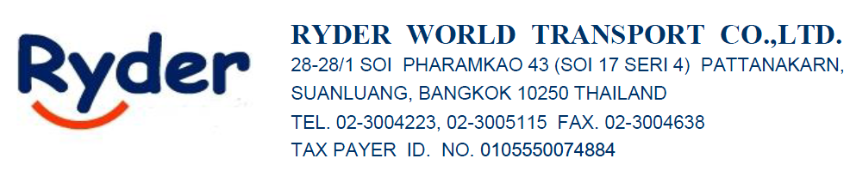20/5/26

ATTN : K.MUT

FROM : Sirisak Srisuwan (Sam) 065-625-4945

AIR FREIGHT RATE QUOTATION (IMPORT-AIR)
Port/Country | Price per K.G. | Flight | T/T | Frequency
Port/Country | +100 +500 | Flight | T/T | Frequency
PVG - BKK | $2.95-$3.1/Kgs |  | 1DAYS | DAILY
SHA - BKK | $3.98-4.1/Kgs | HKG | 3-4DAYS | DAILY
LOCALCHARGE IN BKK
D/O : 800Baht/Set
HDL : 500 Baht/Set
CUSTOM CHARGE : 1,800 Baht/Set
TRANSPORT : 2,500-5,500 Baht
FREE ZONE : 500-1000 Baht

LOCALCHARGE EX-WORK PVG - BKK
DOC ; USD35/SET
EDI : USD25/SET
CUSTOM CLEARANCE : USD35/SET
PICK UP CHARGE : USD120/TRUCK
H.C : USD30/SET
LOCALCHARGE EX-WORK SHA – BKK ( HKG NEED TO WAIT 2-3 DAYS TO CONNECT FLIGH )
DOC ; USD35/SET
EDI : USD30/SET
CUSTOM CLEARANCE : USD55/SET
PICK UP CHARGE : USD130/TRUCK
H.C : USD30/SET

Best Regards,
Sirisak Srisuwan (Sam)
Sales
Ryder World Transport Co., Ltd.
28-28/1 Soi Pharamkao 43 (Soi 17 Seri 4)
Pattanakarn, Suanluang, Bangkok 10250 THAILAND
Tel: (662)300 4223, (662)300 5115 (Ext. 215)
Mobile: (66)65-625-4945
Fax: (662)300 5092
Website: www.ryder.co.th

